CRJ900
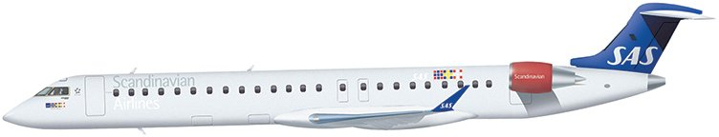
Compartments:
Maximum weights and volumes:
Compartment 1 and 2
Note: All measurements in cm.
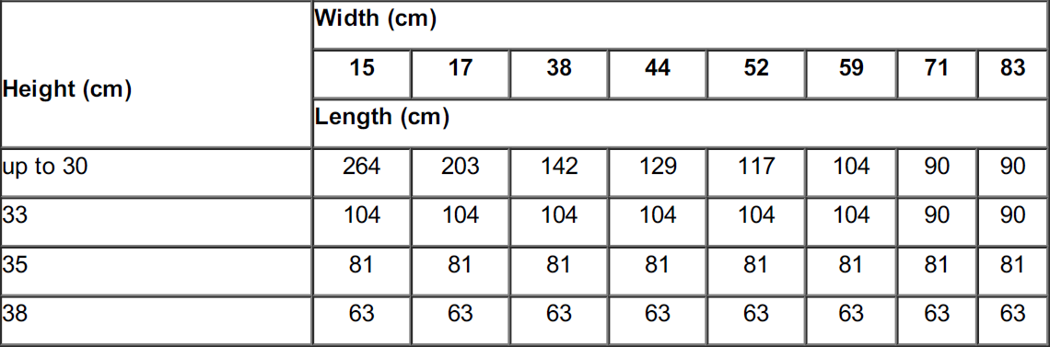
Compartment 6
Note: All measurements in cm.
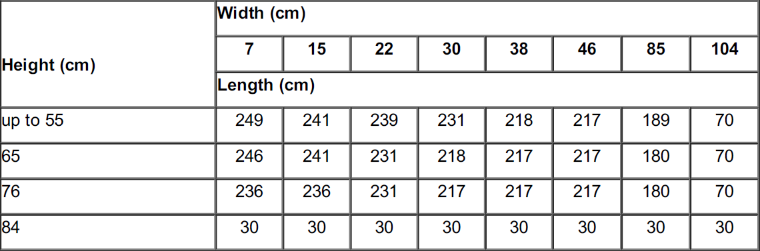
Below is valid for compartment 6.
Caution 1: Take extra care when loading compartment 6 as the cargo door is right below the LH engine. This limits the size of the items possible to load without risking damage to the LH engine cowling.
Caution 2: Due to the critical position of the compartment, relative to the engine cowling, it is prohibited to place the conveyor belt inside the compartment. During loading, the upper side of the conveyor belt shall never be higher than 10 cm above the compartment floor.
Caution 3: If the cargo item is higher than 60 cm, the use of a belt loader is prohibited to prevent damage to the LH engine cowling. Max height loadable in CPT6, is 60 cm.
Air conditioning system:
This table shows the ventilation and heating/cooling possibilities i each compartment.
Topic | Compartment 1 and 2 | Compartment 6
Temperature | Above 2°C at any time (depends on the initial temperature in the compartment) | 16°C - 27°C
Heat | No | Yes
Heat adjust (see Note below) | No | Yes (see Note below)
Cooling | No | Yes
Ventilation | No | Yes
Pressurization | Yes | Yes
Note: If the temperature is +27°C or below, it is not possible to further reduce the temperature with the aircraft’s air conditioning system.
Restrictions:
Dangerous Goods
Dry Ice: Maximum amount in Compartment.
Maximum amount of ICE per compartment
Combined weight
A/C version | Maximum amount  of ICE per A/C | 1 | ​​  6
CRJ900 | 50 kg | 0 kg | ​50 kg

Note: Not to be loaded in the same hold as Live Animals (AVI).
Radioactive Materials: Maximum Transport Index (TI)
 |  |  | Max TI pr. Compartment
A/C version | Max TI pr. aircraft | Max TI pr. package  (or Group of packages) | 1 | 6
CRJ900 | 3 | 3 | N/A | 3

Radioactive Materials: Maximum Package/Group Height and Separation Distance
Maximum Package height and separation distance is not relevant as RRW/RRY can only be loaded in the net section 62 in Compartment 6.

Heavy
The maximum weight per item is 79 kg.
Human Remains
The maximum weight per item is 79 kg.
HUM may be loaded in the same hold as AVI, EAT and LHO, but shall not be loaded in close proximity of these. If possible, use different holds/compartments for the items mentioned above.
Live Animals
Embargo for animals shipped as cargo. This embargo does not apply to tropical fish/fish and crustaceans, as they do not need oxygen during transport.
Cats, dogs, birds and other mammals are permitted as baggage on CRJ 900. Based on the size of the compartments and the expected space needed for bags, cargo and mail on this AC type, embargo for animals shipped as cargo is imposed.
Live Human Organs
Live Human Organs (LHO) shall be loaded in compartment 6, as close as possible to the door section.
Perishables
No aircraft restrictions other than maximum dimensions, area load and maximum load in hold, but always check SIRIUS for current restrictions on origin, destination and possible embargoes.
Sensitive
Load, which is sensitive to shock and tilting (e.g. musical instruments in soft cases) shall not be loaded in the compartments of CRJ. This is due to the risk of damage during loading, stowing and unloading.
Valuable
No aircraft restrictions other than maximum dimensions, area load and maximum load in hold, but always check SIRIUS for current restrictions on origin, destination and possible embargoes.
Vulnerable
No aircraft restrictions other than maximum dimensions, area load and maximum load in hold, but always check SIRIUS for current restrictions on origin, destination and possible embargoes.

Document info:
Author: | Approved by: | Effective date:
Michael Beck, CPHFD | Michael Beck, CPHFD | 03MAY2017
Document review date: | Document review by: | Department:
08SEP2022 | Michael Beck, CPHFD | CPHFD
SCM Document: | SAS Cargo Document: | Live Document:
Yes | Yes | Yes

