A320

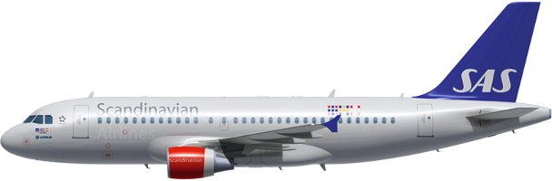

Compartments:

Maximum weights and volumes:

This table shows the maximum weights and volumes per compartment 1, 3, 4 and 5:
Note: NA indicates that volume figure is not given.

Valid for Version 3201

 | Compartment
 | 1 | 3 | 4 | 5
Weight (kg) | 3402 | 2426 | 2077 | 1399
Combined weight (kg) | 3402 | 4503
Area load (kg/m²) | 732 | 732 | 732 | 732
Volume (m³) | 13.28 | 9,76 | 8,54 | 5.92

Valid for Version 32N1/32N2

 | Compartment
 | 1 | 3 | 4 | 5
Weight (kg) | 3402 | 2426 | 2077 | 500
Combined weight (kg) | 3402 | 4503
Area load (kg/m²) | 732 | 732 | 732 | 732
Volume (m³) | 13.28 | 9,76 | 8,54 | 5.92

Maximum dimension tables:

Compartment 1

These tables show the maximum dimensions of cargo items in compartment 1. All measurements in cm.

The dimensions are approximate values and refer to rectangular packages.

Upright Loading.

Upright loading refers to large or heavy packages loaded with the assistance of mechanical ground support equipment and maneuvered through the door in an upright position.
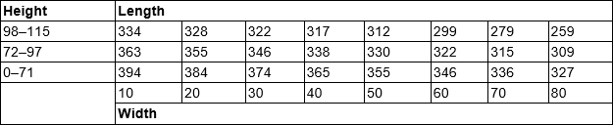
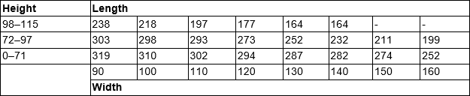
Tilted Loading.
Tilted loading refers to large low density cargo which may require hand maneuvering through the door in a tilted position to avoid obstructions.

Compartment 3 + 4
Upright Loading.
Upright loading refers to large or heavy packages loaded with the assistance of mechanical ground support equipment and maneuvered through the door in an upright position.
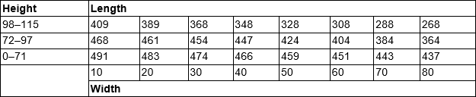
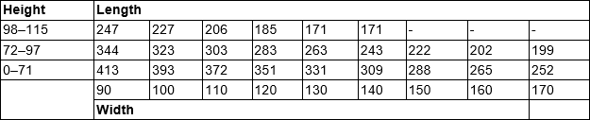
Tilted Loading.
Tilted loading refers to large low-density cargo which may require hand maneuvering through the door in a tilted position to avoid obstructions.
Compartment 5

Items with a height between 65 cm and 85 cm can be loaded via compartment 4.
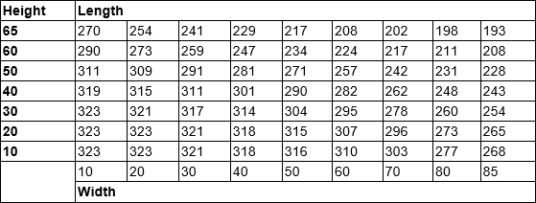
Air conditioning system:
The lower compartments are incorporated in the same pressure system as the passenger cabin and are ventilated and heated only to a certain extent for transportation of live animals.

Restrictions
Dangerous Goods
Dry Ice: Maximum amount in Compartment.
Maximum amount of ICE per compartment
Combined weight
A/C version | Maximum amount  of ICE per A/C | 1 | 1 + 2 | 4 + 5 | 3 + 4 + 5
A320 | 100 kg | 50 kg | - | - | 50 kg
Note: Not to be loaded in the same hold as Live Animals (AVI). (AVF-Aquatics and live fish can be loaded in the same hold as ICE).
For A320 compartment 3-5 is the same hold, therefore AVI cannot be loaded in Cpt 5 if there is ICE in Cpt 3, 4 or 5.
Radioactive Materials: Maximum Transport Index (TI)
 |  |  | Max TI pr. Compartment
A/C version | Max TI pr. aircraft | Max TI pr. package  (or Group of packages) | 1 | 2 | 3 | 4 | 5
A320 | 13 | See note and table below | 4 | N/A | 4 | 4 | 1
Note 1: The maximum allowed TI per package (or group of packages), is depending on the height of the package (or group of packages).
Note 2: Packages in compartment 5 may not be higher than 50 cm.
Radioactive Materials: Maximum Package/Group Height and Separation Distance
The below table shows:
    - The maximum allowed height per package (or group of packages).
    - The minimum separation distance (horizontally) between packages (or groups of packages).
Note: Use the column for Minimum separation distance when:
- the package/group height, or
- the Transport Index (TI)
exceeds the permitted values for grouping packages together.
Transport Index  (TI) per package  (or group of  packages) | Max. height per  package (or  group of  packages) (cm) | Min. separetion  distance  horizontally (cm) | Category
0.0 | No restriction | No restriction | I – White (RRW)
0.0–1.0 | 105 | 100 | II – Yellow (RRY)
1.1–2.0 | 85 | 150 | III – Yellow (RRY)
2.1–3.0 | 65 | 210 | III – Yellow (RRY)
3.1–4.0 | 50 | 255 | III – Yellow (RRY)
More than 4.0 | Not allowed | Not allowed | III – Yellow (RRY)
Note: For the separation of packages (or groups of packages with different Transport Indices (TI), the minimum separation distance required for the package (or group of packages) with the higher transport index must be applied.
Heavy
There are no restrictions regarding HEA other than maximum dimensions, area load and maximum load in hold. HEA shall always be secured by means of lashing. Volumetrically filling the compartment will not be sufficient.
Always check SIRIUS for current restrictions on origin, destination and possible embargoes.
Human Remains
No aircraft restrictions other than maximum dimensions, area load and maximum load in hold, but always check SIRIUS for current restrictions on origin, destination and possible embargoes.
Live Animals

SAS has two animal codes that differ from the IATA standard.

AVC – Crustaceans
AVF - Aquatics and live fish

Note: Crustaceans, aquatics and live fish can be secured by volumetrically filling the compartment. AVC and AVF can be loaded together with EAT, AVF can be loaded together with ICE.

Most live animal shipments must be treated as wet cargo. Therefore, plastic sheeting or tarpaulin must be placed under live animal containers in order to avoid soilage of aircraft holds, ULD’s and other load.

Isolation from Cold Transfer Beneath Animal Cages
Loaded animal cages need to be insulated from cold transfer, as the aircraft does not have heated floors in the cargo compartments. Insulation can be made by various methods, such as: Spreader boards under the cage; insulating material, blankets etc.
Note: If the insulating material also can absorb fluids, the LAR requirement to have plastic under the boxes or cages can be ignored.

 |  | Maximum qty in compartment (kg)
Group | Animal, Example | 1 | 3 + 4 + 5
1 | Tropical fish, fish | No limit | No limit
2 | Shrimps, reptiles, snakes, crabs, frogs, oysters | No limit | No limit
3 | Cats, dogs, other pets | See note ¹
4 | Other animals | 100 | 100
Note: [1] All AVIH shall be loaded in the aft hold (Compartment 3–5).

Number of Animal Cages | Flight Time:  Less than 4 h | Flight Time:  4 hours and Above
1 | Plan the crate in net section 31–42. No other load is allowed in the chosen net section. | Plan the crate in CPT 5, no other load allowed in CPT 5  or,  Plan the crate in net section 41 or 42, no other load allowed in these two sections.
2 | Plan both crates in net sections 41 and 42. No other load allowed in these net sections. | Plan the first crate in CPT 5 and second in net section 42. No other load allowed in these two sections
- For A320, compartment 3-5 is the same hold, therefore AVI cannot be loaded in Cpt 5 if there is ICE in Cpt 3, 4 or 5.

Live Human Organs

Live Human Organs (LHO) shall be loaded close to the cargo door.
Live Human Organs (LHO) may be loaded in the cabin with the commander’s approval.
Restriction: Separate from Radioactive materials by at least 0,5 meters.
Perishables
No aircraft restrictions other than maximum dimensions, area load and maximum load in hold, but always check SIRIUS for current restrictions on origin, destination and possible embargoes.
Sensitive
No aircraft restrictions other than maximum dimensions, area load and maximum load in hold, but always check SIRIUS for current restrictions on origin, destination and possible embargoes.
Valuable
No aircraft restrictions other than maximum dimensions, area load and maximum load in hold, but always check SIRIUS for current restrictions on origin, destination and possible embargoes.
Vulnerable
No aircraft restrictions other than maximum dimensions, area load and maximum load in hold, but always check SIRIUS for current restrictions on origin, destination and possible embargoes.

Document info:
Author: | Approved by: | Effective date:
Michael Beck, CPHFD | Michael Beck, CPHFD | 01MAR2021
Document review date: | Document review by: | Department:
15FEB2023 | Michael Beck, CPHFD | CPHFD
SCM Document: | sascargo.com: | Live Document:
Yes | Yes | Yes

